Source: New York Passenger Lists 1820-1891 {by Glenn Schilberg, 10/18/2020}
Ship Suevia passenger record for Gottlieb Schilberg family, June 7-23, 1882, New York Ellis Island
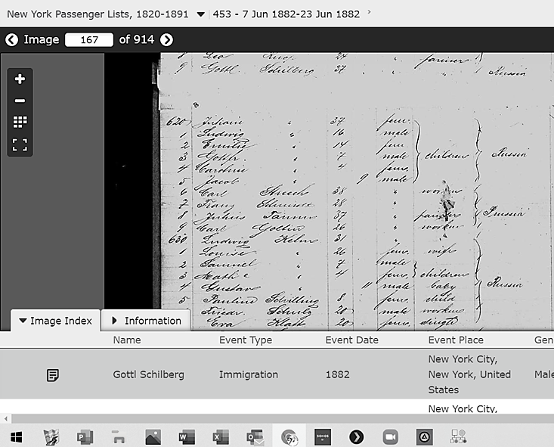Note: Gottlieb Schilberg’s first name abbreviated as Gottl. [record #619]; rest of family are #620-625 except that daughter Pauline is shown separately as Pauline Schilling, age 8 [record #635].
Wife Julia is shown as Juliane; daughter Carrie is shown as Caroline; Ludwig later Americanized his name to Louis and Gottfried [shown as Gottfr.] also Americanized to Fred. Infant Jacob is not known elsewhere in family history but there are one or two graves marked “Infant” in the Hatchett cemetery, Bessie OK, in the family plot where Gottlieb, Julia, and several other family members are buried.
Although Gottlieb was born in Poland, that part of the country had been annexed by Russia by the time of his emigration, so the family nationality is listed as Russia. Much of Poland had been partitioned to Prussia, Austria and Russia through the 1800’s.

